JOB PACK | TECHNICAL COORDINATOR
OCTOBER 2020

La Boite | Your Voice, Your Stories, Your Theatre

La Boite is an iconic Australian theatre company and one of Queensland’s most respected producing houses. As Australia’s oldest continuously running theatre company, La Boite has created inspiring, innovative, and adventurous theatre for over 95 years.
La Boite understands that the stories, ideas and voices of our city and country are many and varied and as such seeks to represent and engage in this rich diversity of form, ideas, ethnicity, gender and identity.

La Boite is committed to building workplace diversity, access and inclusion. Diversity is central to innovation, and access and inclusion are key to unlocking its potential. La Boite’s diversity will be reflected in its programming and storytelling, as well as in its workforce, audiences, artists and partnerships. La Boite encourages applications from Indigenous Australians, people with disability, people from diverse cultural and linguistic backgrounds and lesbian, gay, bisexual, transgender and intersex (LGBTQIA+) people.

We actively seek out collaborations with exciting partners to create new work and expand the possibilities of form. In the past, La Boite has presented work with Brisbane Festival, Circa, Sydney Theatre Company, Belvoir, Griffin Theatre Company, Opera Queensland, Dead Puppet Society, The Farm, Playlab Theatre and QUT Creative Industries.

Vision
To be Australia’s most diverse theatre company.

Mission
To create powerful connections between artists and audiences through stories that entertain, move, empower, surprise and transfix.

We Value

RELATIONSHIPS. La Boite is people-centred, embedding a mindset of thoughtful risk-taking, creativity and innovation while being responsive to our partners’ shared strengths and aspirations, and enhancing audience expectations.

RESILIENCE. Through a passionate dedication to diversity, La Boite will thrive with considered, confident and connected strategies that strengthen the company.

REPUTATION. La Boite will continue to grow and strive for greater profile, cementing its role as a vital cultural hub in Brisbane, Queensland and Australia while also distinguishing itself globally as a passionate and necessary storytelling institution.

SUSTAINABILITY. La Boite will strengthen its sustainability and independence through commercial growth, enabling increased artistic and audience development.

Alex Lee, Courtney Stewart and Hsiao-Ling Tang in Single Asian Female by Michelle Law, 2017
Photo by Dylan Evans

ABOUT THE JOB | TECHNICAL COORDINATOR

La Boite Theatre is seeking a motivated and dynamic Technical Coordinator.

The Technical Coordinator reports to the La Boite Production Manager and ensures the highest quality technical operations, as well as maintain and strive to improve all technical aspects of company productions and activities.

La Boite is a unique workplace and offers incredible opportunity to grow and ‘own’ your job. The ideal person will possess a positive attitude, a forward-thinking innovative approach to tackling new challenges and be embedded in a similar creative industry. This position is an excellent opportunity for a motivated technician who thrives in a fast‐paced and creative environment, who enjoys problem solving and working with artists to realise their vision. They will bring with them a keenness to offer technical expertise while still getting their hands dirty given the nature of the small but nimble team.

The position is full‐time and based in Brisbane with some travel and outside work hours required.
The ideal person will love working in a fast-paced and creative environment.

La Boite is committed to building workplace diversity, access and inclusion. Diversity is central to innovation, and access and inclusion are key to unlocking its potential. La Boite’s diversity will be reflected in its programs and storytelling, as well as in its workforce, audiences, artists and partnerships. La Boite encourages applications from Indigenous Australians, people who are d/Deaf or disabled, people from diverse cultural and linguistic backgrounds and lesbian, gay, bisexual, transgender and intersex (LGBTQIA+) people.

Overview

Hours: Base 38 working hours per week. To be worked on a flexible roster as determined by the Production Manager.
Out of hours work is expected with this position.

Reporting to: This position reports to the Production Manager.

Supervising: The position supervises casual technical staff.
Additional Conditions:
Qualifications/licences required: Safe Work at Heights, First Aid Certificate, manual Open driver’s licence, EWP
Skills required: Vectorworks
Qualifications/licences optional: Restricted Electrical Licence, Rigger License

La Boite Theatre values the importance of a work/life balance and flexible working hours are available.

Goal
To ensure the highest quality technical operations and support for La Boite Theatre as well as maintain and improve all technical aspects of the company productions and activities.

Duties
- To be responsible for the technical aspects of all La Boite productions and activities - in the Roundhouse Theatre, other local venues and on tour.
- To provide technical advice and support to all events and activities in the Roundhouse Theatre, including all La Boite Productions and Venue Hires.
- To oversee ongoing venue operations and maintenance, and manage the safe, effective installation, maintenance and use of technical equipment, (incl. lighting, sound, video, rigging and staging elements).
- To provide board operation and fulfil Head LX duties for La Boite productions as required.

Duties and Responsibilities

- To be responsible for the technical aspects of all La Boite productions and activities - in the Roundhouse Theatre, other local venues and on tour.
  - Source, create, update and interpret venue and design production plans and specifications in CAD based Vectorworks, in coordination with the Production Manager.
  - Provide detailed information and advice regarding venue and/or specific production issues.
  - Provide advice and feedback on technical aspects of productions, including but not limited to electrical safety, loadings, rigging, transport and WHS.
  - Accept responsibility for the identification and provision of operational and technical elements of all company activities.
  - Assist with all technical requirements of a show or areas assigned by the Company.
  - Coordinate hire and/or purchase of equipment as required.
  - Attend La Boite Theatre staff meeting, production meetings and other meetings as required.
  - Utilize troubleshooting and problem-solving techniques to resolve operational, manufacturing and maintenance problems to ensure minimum costs and prevent operational delays.

- To provide technical advice and support to all events and activities in the Roundhouse Theatre, including all La Boite Productions and Outside Hires.
  - Provide customer focused technical support prior to and during outside hire events.
  - Actively pursue opportunities for Roundhouse Theatre equipment Dry Hires and be responsible for associated documentation and reporting.
  - In co-ordination with FOH staff ensure the smooth running of company events and maintain customer focus.
  - Assist Production Manager in the creation and maintenance of accurate venue information.

- To oversee ongoing venue operations and maintenance, and manage the safe, effective installation, maintenance and use of all technical equipment, (incl. lighting, sound, video, rigging and staging elements).
  - Comply with and actively contribute to safe work practices.
  - Assist the Production Manager in coordinating and actioning all venue and equipment maintenance including annual Test & Tag.
  - In consultation with the Production Manager, establish & update operational procedures, technical requirements, asset register and other documentation.
  - Provide comprehensive reports to Production Manager and General Manager as required.
  - Supervise, train and coordinate all technical staff throughout the production process ensuring the bump-in, performance and bump-out is done in an effective and safe manner.
  - Encourage, foster and support upcoming technicians and support the artistic endeavours of practitioners involved.

- To provide board operation and act as Head LX for La Boite productions as required
  - Fulfil duties as Head LX and crew member on all La Boite Theatre Main Stage Productions.
  - Provide board operation and Duty Tech duties for OUTSIDE HIRES where required.

- Other
  - Comply with La Boite’s Workplace Health and Safety Policy and actively promote safety in the workplace.
  - Comply with La Boite’s policies and procedures and with relevant legislation and regulations.

- Desirable
  - Experience with new technologies and working with audio and visual equipment, including vision mixers.
  - Understanding of video editing and production.
  - Familiar with the Zoom platform and technology, and Zoom Rooms technology.
  - Demonstrated ability to adapt to new technologies; troubleshoot technological problems; use technology to increase productivity; keep technical skills up to date.

How to Apply
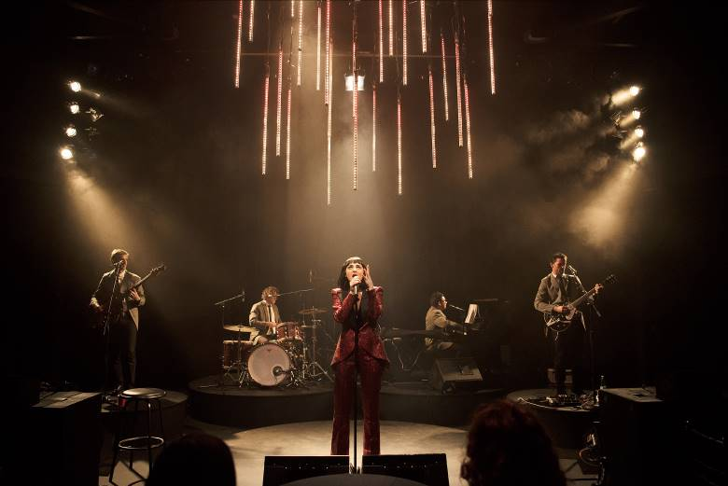
Your application should include the following:
- A cover letter highlighting your key skills and experience
- A current resume, including contact details for two referees

Please email your application by midnight Monday 26 October 2020 with Technical Coordinator

If you would like more information about the role, please email jobs@laboite.com.au or call Production Manager, Stu Syme on 07 3007 8600.

Andrew Johnson, Mik Easterman, Naomi Price, Michael Manikus, Jason McGregor
In La Boite and The Little Red Company’s Lady Beatle - image by Dylan Evans

